//HOME TASK 3

//MUHAMMAD AHMAD RAZA

//467253

#include<iostream>

using namespace std;

int main(){

//PROJECT 1

char x,p,s,b,k;

cout<<"ENTER 'p'for punjab"<<endl<<"'s'for sindh"<<endl<<"'k'for kpk"<<endl<<"'b'for balochistan"<<endl;

cin>>x;

switch(x){

case'p':

cout<<"110 million "; //giving population of provinces

break; // applying cases for each provinces

case's':

cout<<"56.3 million ";

break;

case'k':

cout<<"40.8 million ";

break;

case'b':

cout<<"21.7 million ";

default:

cout<<"PLZ ENTER CORRECT "; //if letter is not written correct

break;

}

}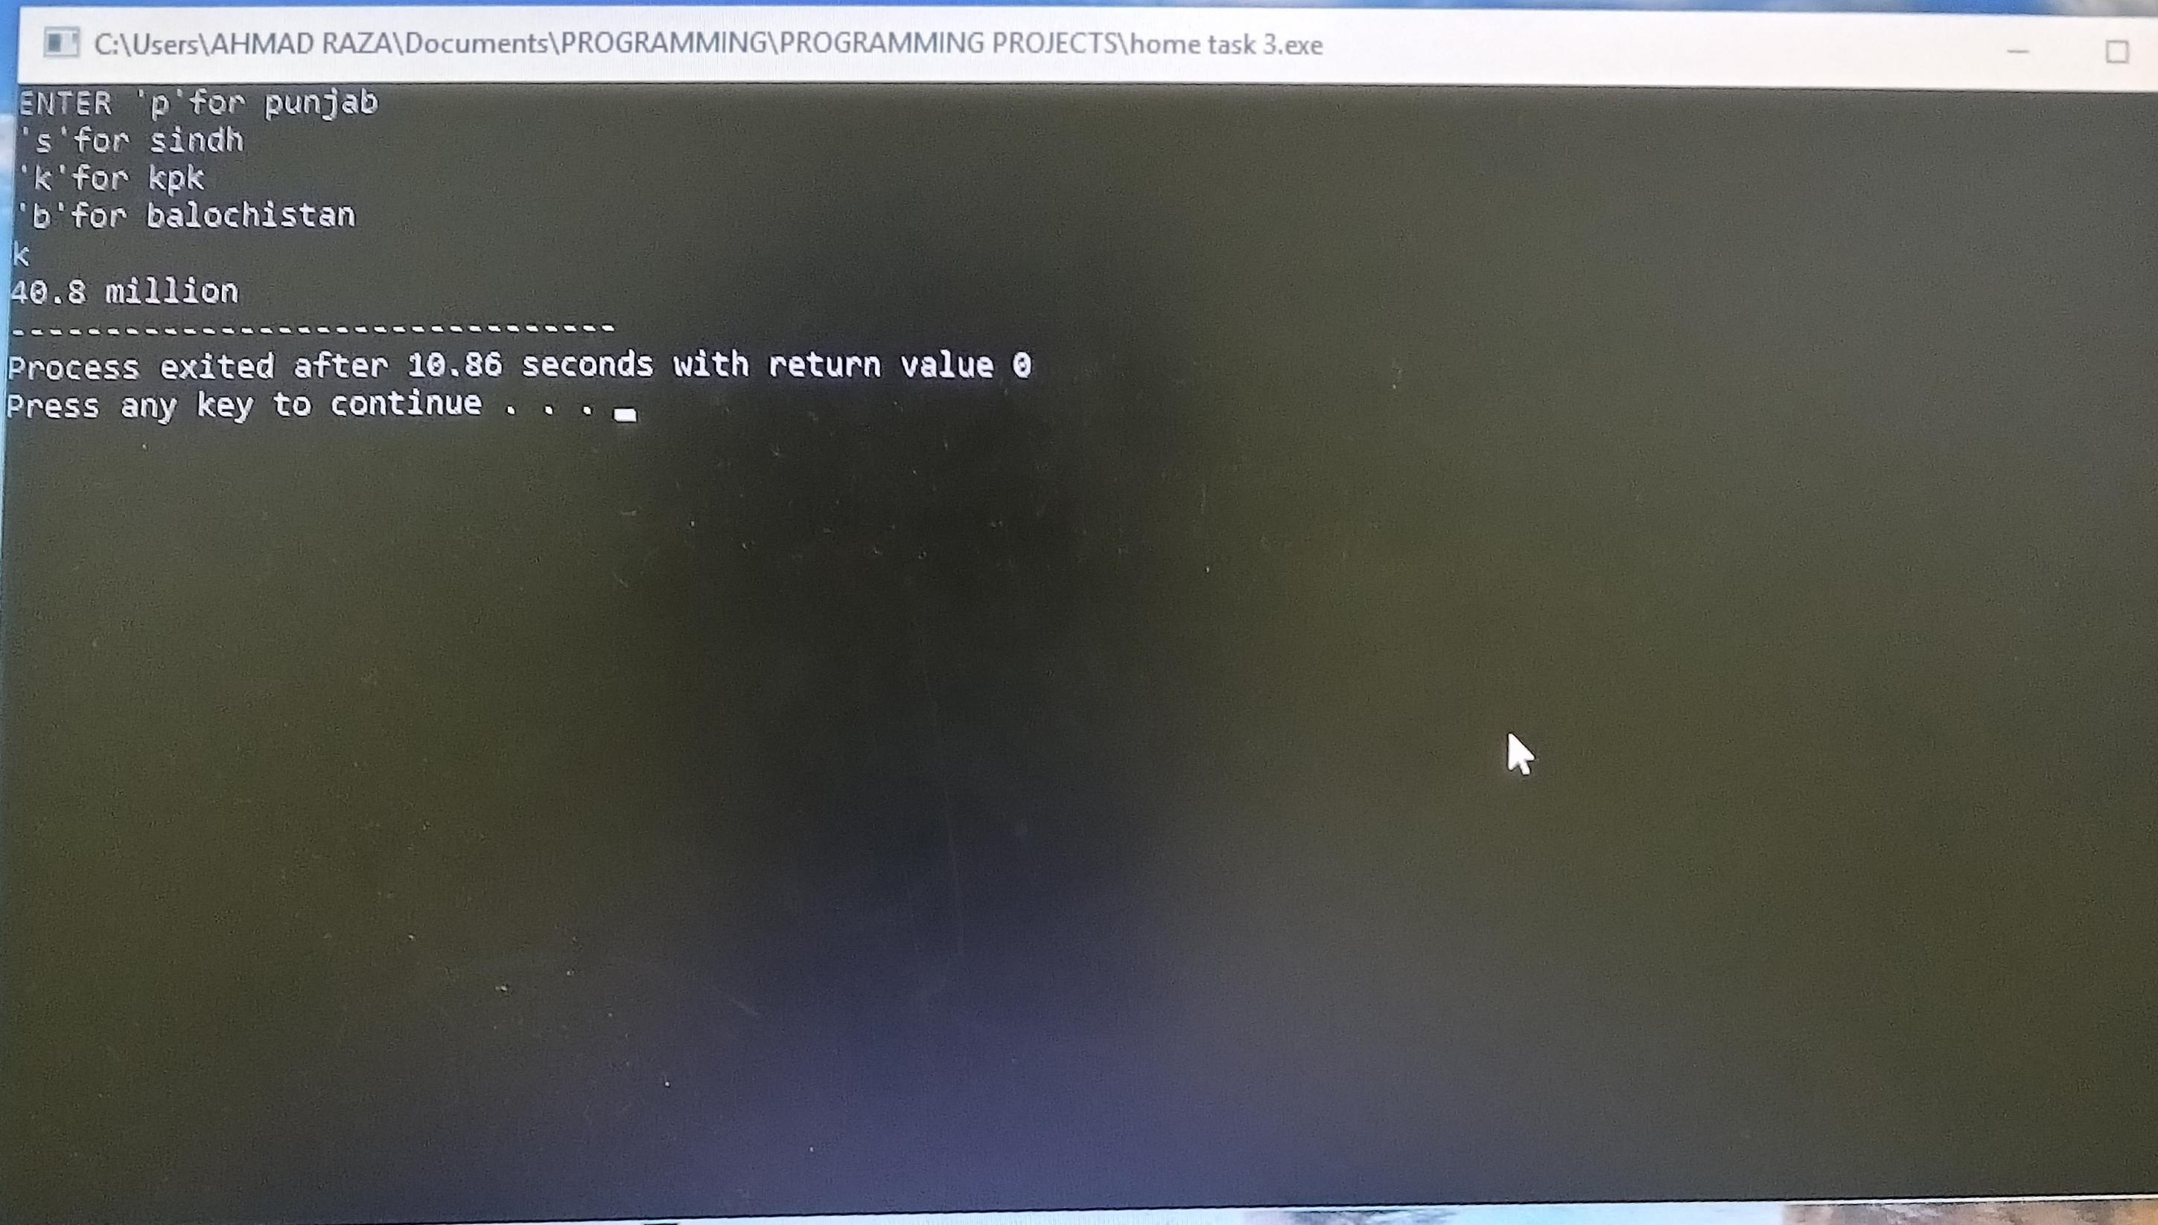

//PROJECT 2

char x,a,e,i,o,u;

cout<<"ENTER ALPHABELT: "<<endl; //taking input

cin>>x;

switch(x){

case'a': //checking wheather input is vowel

case 'A': //or a consonent

case'e':

case'E':

case'i':

case'I':

case'o':

case'O':

case'u':

case'U':

cout<<"ITS A VOWEL ";

break;

default:

cout<<"ITS CONSONENT ";

break;

}

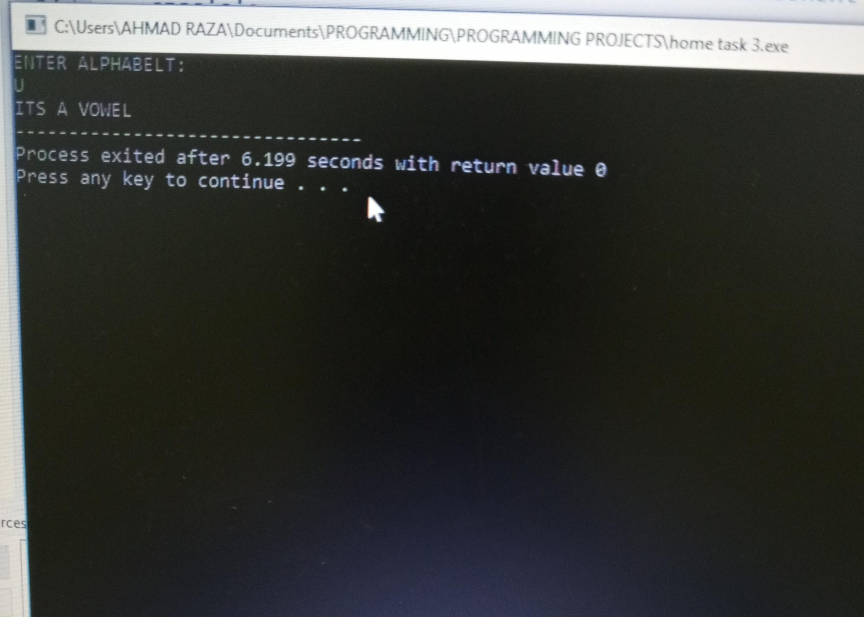}

//PROJECT 3

int a,b;

cout<<"ENTER THE NO= "<<endl; //taking input

cin>>a;

if(a==0){

b=0; //defining no and their range

}

else{

if(a<0){

b=1;

}

else{

b=3;

}

}

switch(b){

case 1:

cout<<"its a negative no "; //checking wheather input is positive

break; //negative or zero

case 3:

cout<<"its a positive no ";

break;

case 0:

cout<<"its zero ";

break;

}

}

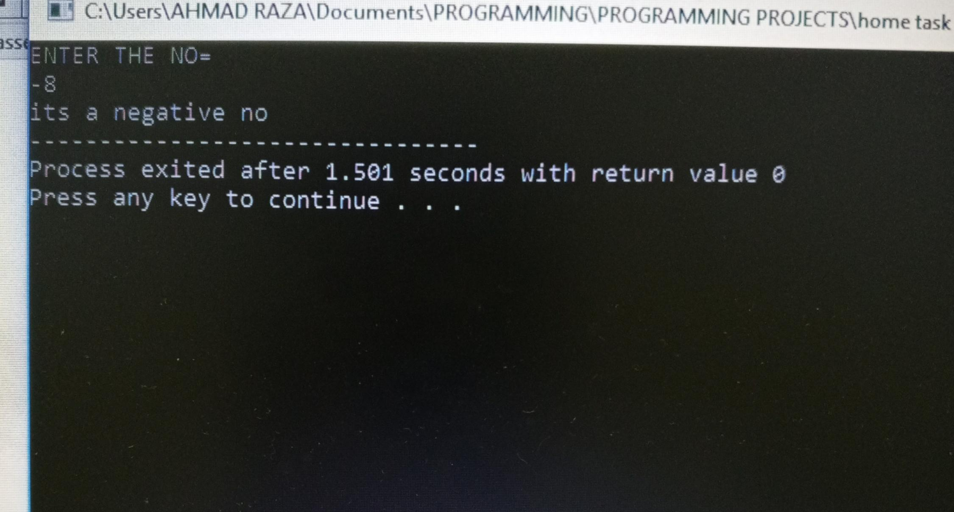

//PROJECT 4

float age;

cout<<"ENTER THE YOUR AGE"<<endl; //taking input of age

cin>>age;

if(age>=1&&age<=12){

cout<<"YOU ARE CHILD";

} //defining range of age for different categories

else{ //like child, teenagers and adult.

if(age>12&&age<=17){

cout<<"YOU ARE TEENAGER";

}

else{

if(age>17){

cout<<"YOU ARE ADULT";

}

}

}

}

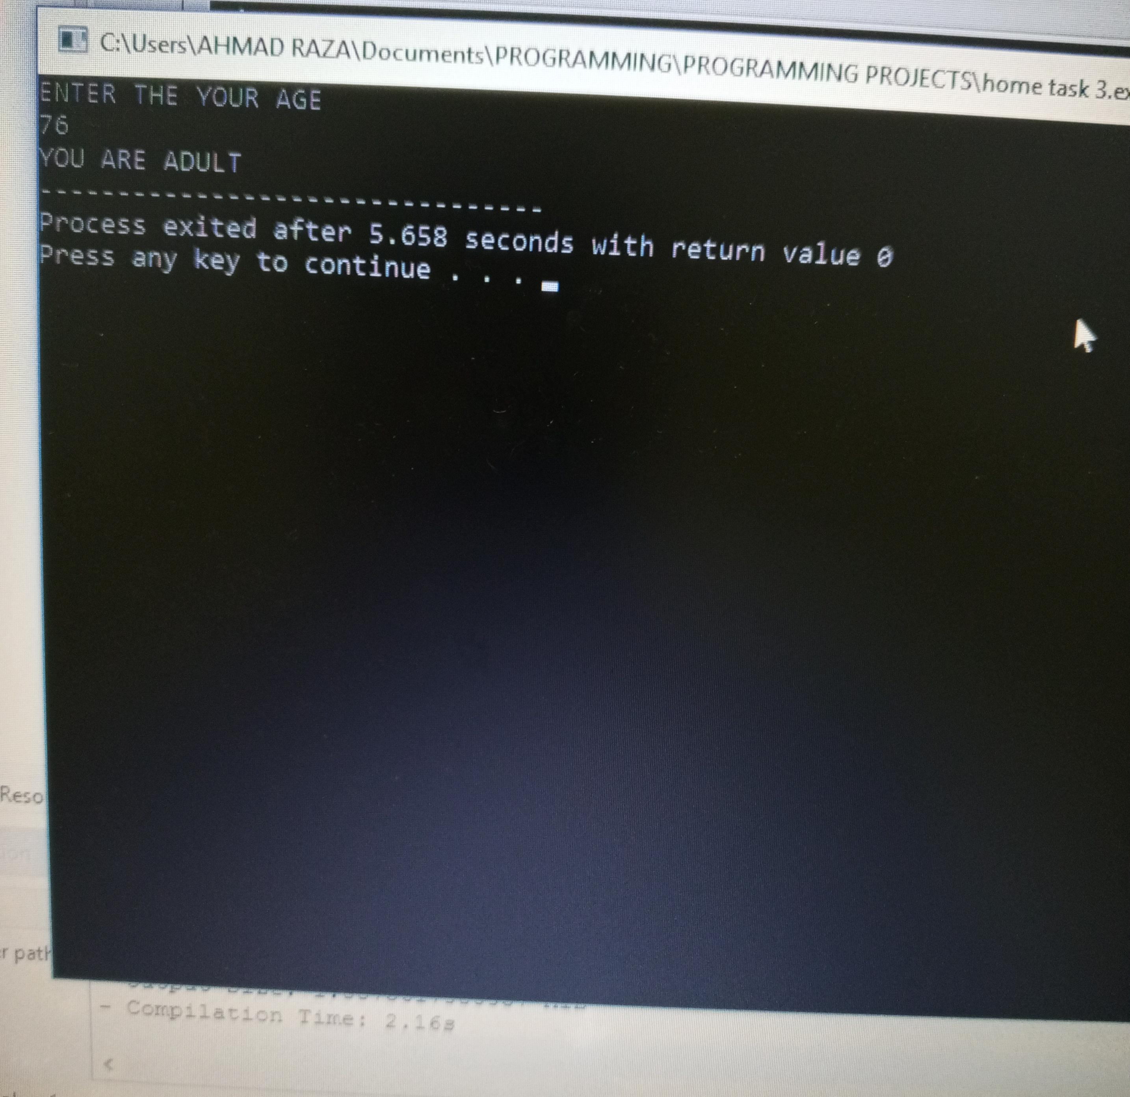

//PROJECT 5

int a,b,c,n;

cout<<"ENTER THE NUMBERS:"<<endl; //taking 3 input numbers.

cin>>a>>b>>c;

if(a>b&&a>c){

cout<<"GREATEST NO = "<<a;

} //applying conditions to print

else{ //greater no among that 3 no

if(b>a&&b>c){

cout<<"GREATEST NO = "<<b;

}

else{

if(c>b&&c>a){

cout<<"GREATEST NO = "<<c;

}

}

}

}

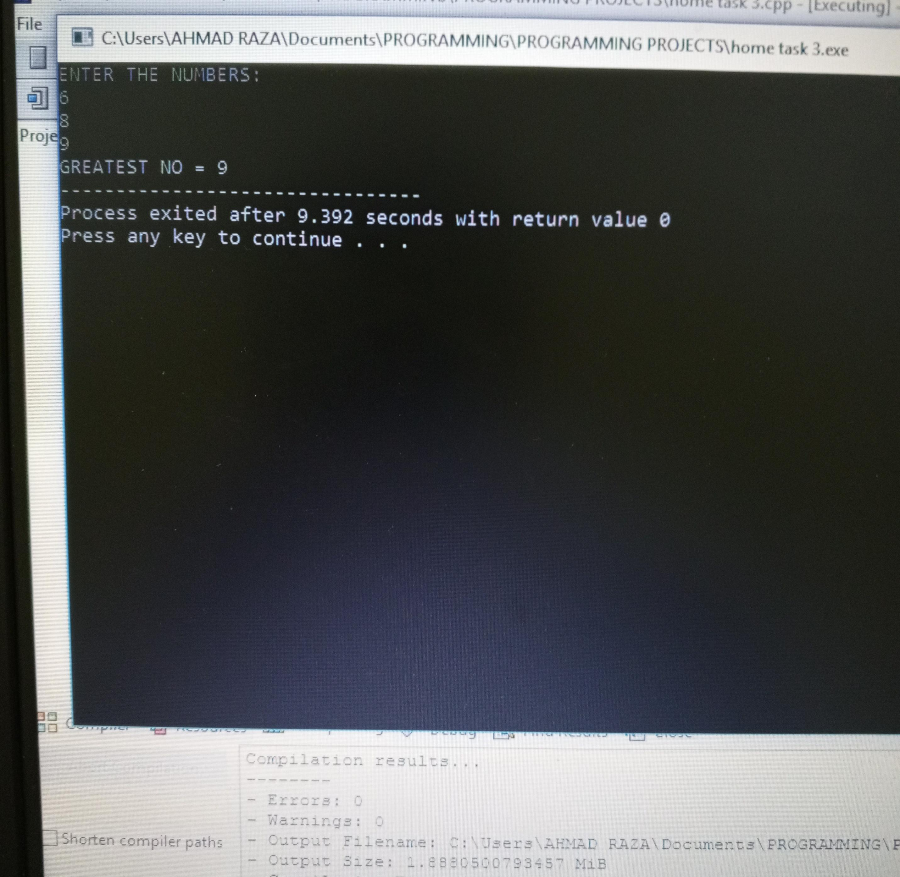

//PROJECT 6

char v,a,A,e,E,i,I,o,O,u,U;

cout<<"ENTER THE ALPHABETS"<<endl; //taking alphabets as input.

cin>>v;

if(v==a||v==A){

cout<<"ITS VOWEL";} //applying conditions wheather input

else{ //alphabet is vowel or consonent

if(v==e||v==E){

cout<<"ITS VOWEL";}

else{

if(v==i||v==I){

cout<<"ITS VOWEL";}

else{

if(v==o||v==O){

cout<<"ITS VOWEL";}

else{

if(v==u||v==U){

cout<<"ITS VOWEL";}

else{

cout<<"ITS CONSONENT";

}

}

}

}

}

}

